# **ABSTRACT**

State election results in India provide a diverse and distinct set of insights, very contrary to popular belief. It is often sort of hard to the political prospects in the area, and even sort of pretty much more difficult to communicate to an audience that is not fully involved with the community in accordance with the design, or to a crowd beyond the region, contrary to popular belief, which is quite significant. While global news outlets specifically kind of do State elections have primarily been lacking critical examination and perceptive knowledge transfer to a significant degree, despite the fact that federal elections have done a fantastic job of analysis and communication., kind of contrary to popular belief. In this project, a series of interactive approaches for visualization but also designed for presenting very complex insights using data from Tamil Nadu elections for its state's legislature from 2016 to 2021 for all intents and purposes are actually completed by using Power BI in a for all intents and purposes basically big way, so while global National elections actually have mostly been absent of rigorous research and insightful information interchange to a major degree, or so they are mostly assumed.

**TABLE OF CONTENTS:**

|  |  |  |
| --- | --- | --- |
| **CHAPTER**  **No.** | **TITLE** | **PAGE NO.** |
|  | **ABSTRACT** | I |
|  | **LIST OF FIGURES** | II |
| 1. | **INTRODUCTION** | **5** |
|  | 1. INTRODUCTION |  |
|  | 1.1 DATA COLLECTION |  |
|  | 1.2 PROBLEM STATEMENT |  |
|  | 1.3 BUSINESS OBJECTIVE |  |
| **2.** | **DATA PREPARATION AND MODELING** | **12** |
|  | 2.1 DATA CLEANING |  |
|  | 2.2 DATA TRANSFORMATION |  |
|  | 2.3 DATA MODELLING |  |
| **3.** | **DATA ANALYSIS AND INTERPRETATION** | **17** |
|  | 3.1 DATA ANALYSIS |  |
|  | 3.2 PUBLISHING DASHBOARDS |  |
|  | 3.3 INFERENCE |  |
| **4.** | **CONCLUSION** | **27** |
|  | 4.1 RECOMMENDATIONS |  |
| **5.** | **REFERENCES** | **29** |
|  |  |  |
|  |  |  |
|  |  |  |

**CHAPTER 1**

**INTRODUCTION**

**1.Introduction**

Information graphics and interactive visualizations basically are growing closer together components of definitely Contrary to common opinion, social media is an actual social print and digital technology, encompassing publications, web news sites, websites, discussion forums, and more. The capacity of visualization techniques to typically depict enormous volumes of complicated data as a narrative basically is the pretty primary reason for their widespread acceptance in a subtle way.

Digital media for all intents and purposes has an advantage over print media in that it can specifically include contacts, motions, changes, graphics, sounds, and voluminous data in addition to the storyline, or so the for all intents and purposes thought. the aid in the sort of effective communication of data-driven insights during the knowledge discovery process in a kind of major way. There mostly are many possibilities to really draw conclusions from large amounts of data and the type presents them sort of more effectively for improved decision-making, or so the really thought Humans have an organizational level and visual system that enables with to swiftly analyze material in order to reflect, roughly detect patterns, and generally compare it to other comparable types of things with have met in the past, or so the usually believed.

Humans have organizational levels and visual systems that are enabled to swiftly analyze material in order to reflect, roughly detect patterns, and generally compare it to other comparable types of things which have met in the past, or usually believed. But complex and multifaceted data that takes the form of columns or factorization restricts with ability to see the connection between a variety of variables at once, showing how multi-faceted data presented in the form of graphs or matrices restricts with ability to see the connection between a variety of variables at once in a generally significant way.

Digital media has an advantage over print media in that it can include interactions, movements, transitions, animations, sound effects, and dense data in addition to the storyline. the aid in the effective communication of data-driven insights during the knowledge discovery process. However, multidimensional data presented as tables or matrices restrict the capacity to simultaneously visualize the link here between a number of variables. Using creative graphic representations, which can combine data elements and create meaningful relationships to make it simple to compare object sizes, make it easier to understand the nature of the data, and provide a better perspective on recent advances. Additionally, the dynamic nature of visualization engages readers by enabling independent detail exploration at multiple levels of information specificity.

**1.1** **Data Collection**

The dataset for all intents and purposes is directly collected from the official website of Indian election commission of India, sort of further showing how search results mostly are labeled at the federal, state, county, and city levels. So, before beginning to collect data, rethought and reviewed all research objectives. Begin by compiling a list of goals. Here are some critical questions considered,

What is the purpose of the investigation?

What kind of information is gathered?

What certain techniques and approaches for gathering data are used to collect, store, and process the data?

Ineffective data is never beneficial. So that's why the collection of high-quality ones has been gathered.

**What is the purpose of the investigation?**

The investigation clearly suggested collecting the data set ranging from three years which will give a tremendous visualization to the people.

**What kind of information is gathered?**

Depending on the objective of research, gathered quantitative data, which is only numerical data. The data set includes extremely useful data such as political party names, their abbreviations, candidate names, their personal details and the result percentage.

**What techniques and policies are employed to gather, keep, and process the information?**

The variety of unfamiliar techniques are utilized to gather the needed data set. Listed below are a few popular techniques used for data collection:

● Survey

● Interviews and focus groups

● Record and documents

● Secondary data gathering

**1.2** **Problem Statement**

Every five years, elections are held in Tamil Nadu to choose the State assembly and a portion of the state's representatives to the Lok Sabha. There are 39 Lok Sabha seats and 234 assembly seats in total. Since independence, the state has held 16 Lok Sabha elections and 15 assembly elections. There are 234 assembly districts in Tamil Nadu. The Chief Minister of the state is chosen by lawmakers from the political party or coalition that holds a majority in the assembly. The Chief Minister is appointed for a five-year term with the option of re-election. The main factor is to analyze immense quantities of huge datasets and then PowerBI will be used to carry out the visualization.

## **Business Objective**

* To compare and analyze the assembly elections in Tamil Nadu.
* To analyze the better performance of parties in Tamil Nadu and leaders in Tamil Nadu.
* To analyze the role played by an alliance.
* To analyze the election results of various years.

**Category 1**

* Results of the Tamil Nadu Assembly election 2011
* Results of the Tamil Nadu Assembly election 2016
* Results of the Tamil Nadu Assembly election 2021
* Compare the Assembly elections of the years 2011 & 2016
* Compare the Assembly elections of the years 2021 & 2016
* Compare the Assembly elections of the years 2011 & 2021
* Total Number of parties participated
* Total votes polled gender wise
* Results of the year 2016 alliance named Makkalin mudhal kootani
* Which alliance won the results of 2021

**Cate** **gory 2**

* Visualize the party leader’s gender
* Illustrate the success of the alliance by the leader
* Most liked leader of people’s choice
* Ask any questions about the data
* Success rate of the leader named Seeman
* Longest party that is established so far
* Success rate of the party heads
* Does the leader named Vaiko hold an alliance
* List the top 3 alliances
* Count of male leaders and female leaders

The main idea behind the separation of the categories is to provide the essential details to the viewers. The first category focuses more on the party and the year. The main focus will be the year the first category is able to deliver an outstanding visualization year-wise.

As year plays a major role, and considering year as one of the important factors, it is able to categorize and deliver business objectives to the audience more in a way that is clear. There is also an important feature of the dataset is the alliance. The major purpose of categorizing things differently is to provide viewers access to the information that is needed. The second group places more emphasis on the party leader. The leader will be the center of attention, and party leaders can offer excellent visualization. Since the year is a significant factor and plays a significant function, it helps with identifying and communicating business purposes to the audience more clearly. The alliance is another crucial component of the dataset.

# **CHAPTER 2**

# **DATA PREPARATION AND MODELING**

# **2.1 Data Cleaning**

The data from your selected query appears in the center of the Power Query Editor screen, and the list of available queries is on the left. All of the actions you perform to shape your data while using Power Query Editor are documented. Then, the query automatically applies your instructions each time it establishes a connection to the data source, ensuring that your data is always shaped as you specified. You can trust that changes to your original data source are being made since Power Query Editor only alters a specific view of your data. The text and CSV data are converted to the proper format as part of the cleaning procedure.

**Cleaning template used**

**Step 1:** **Eliminated redundant or pointless observations**.

Removed duplicate or pointless observations as well as undesirable observations from the dataset. The majority of duplicate observations will occur during data gathering. Duplicate data can be produced when combining data sets from different sources, scrape data, or get data from clients or different departments. One of the most important factors to take into account in this procedure is deduplication. When observing observations that do not pertain to the particular issue that are attempting to study, those observations are deemed irrelevant. We eliminated those useless observations.

**Step 2:** **Fixing the structural issues**

When measuring or transferring data and find odd naming practices, typos, or wrong capitalization, such are structural faults. Mislabeled categories or classes may result from these inconsistencies. Here we cleaned both "N/A" and "Not Applicable," were categorized as different but they should be assessed as belonging to the same category.

**Step 3: Handle any missing data**.

The truth is that moving forward despite insufficient data might not be an ethical course of action. There are a few options for handling missing data. Although neither is ideal, both can be taken into account. We typically drop observations with missing values as a first resort, but remember that doing so will also drop or lose information.

Another method is to fill in the missing values based on other observations, but this again runs the risk of compromising the data's integrity because we might be working with assumptions rather than actual facts. Taking these all into consideration we handled the missing data in a manner that will not affect our analysis.

## **2.2 Data Transformation**

For its targeted analytical use case, the data is changed and consolidated in this place.. The data is refined after it has been successfully extracted. Sorted, organized, and cleaned data are performed on it during the transformation process. To produce data that is dependable, consistent, and usable, for instance, duplicate entries will be removed, missing values removed or enriched, and audits will be carried out. The phase of this project involves the following tasks:

● Cleansing, purifying, eliminating duplication, renaming, and switching data kinds.

● Conditional column creation,

● Performing calculations using DAX measures, Splitting columns.

**Promoting Headers**

Open the power bi desktop and import the data from the get data ribbon and then select the excel workbook data, the Tamil Nadu won percentage data is imported, then click on the transform tab

Click on the “use first row as headers” and thence by promoting the headers

Then change the query name to Won percentage

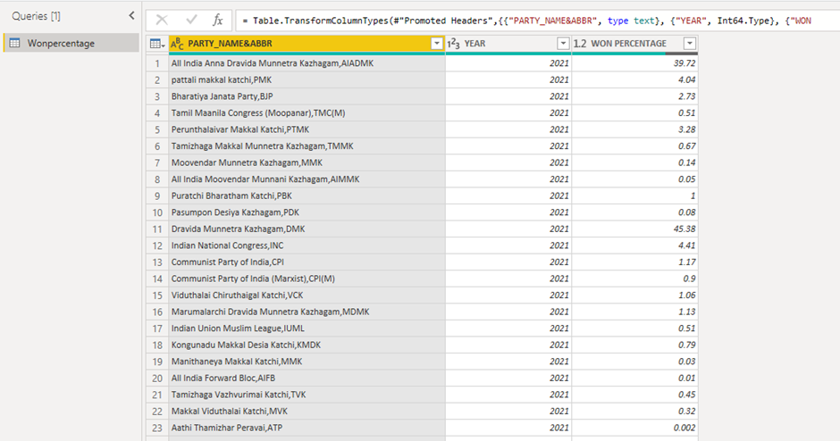

Figure 2.1 Power Query Editor After Promoting Headers

**Split Columns By Delimiter**

Now the column PARTY_NAME&ABBR is split by the constrained delimiter of the comma. After that changing the column names

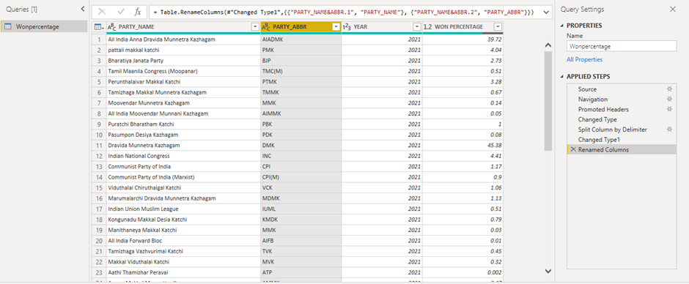

Figure 2.2 Query After Splitting the Columns By Delimiter

**Dax Measures**

**Removing null values**

Replacing all the null values can be done by many methods like filtering using DAX.



Figure 2.3 Dax Measure for Replacing Null Values

**Creating a new column**

Here a new column is created by using the DAX measure which is mentioned below

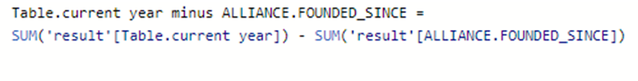

Figure 2.4 Dax measure for creating a new column

**Count measure**



Figure 2.5 Dax count measure

**Merging queries**

Two tables are needed for the merge operation. Hence select the tables of required configuration and merge, then expand the table that is select all the columns which are only necessary.

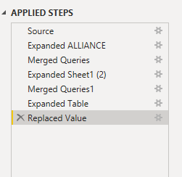

Figure 2.6 Merging two queries

**2.3 Data Modelling**

Data modeling is the act of describing and evaluating all the many types of data that the company produces and collects. In the Model view click on the model that has been generated.

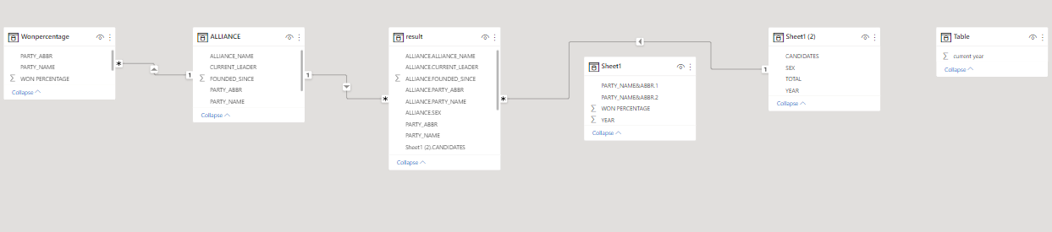

Figure 2.7 Data modeling

# **CHAPTER 3**

**DATA ANALYSIS AND INTERPRETATION**

# **3.1 DATA ANALYSIS**

# The analysis of the Tamil Nadu assembly election will be mostly based on the Constitution and its results. The analysis will be accomplished by using the data visualization tool which is Power BI. For the analysis, the data will be first collected and then the processing operations like the transformation of the data set will be performed. It effectively prepares data for analysis and business intelligence processes, allowing data analysis to deliver actionable business information.

# **Results Of The Tamil Nadu Assembly Election**

First of all drag a slicer and place the field year into it, as the year places the major role there will be three years which are 2011, 2016 and 2021. Then create two individual slicers which are alliance and party name Adding additional design to our chart we will be inserting a shape and featuring it then we will be placing the slicer over it

## **3.2 Publishing Dashboard**

## A Power BI dashboard is a single page, also known as a canvas, that uses visualizations to tell a story. A well-designed dashboard presents only the highlights of that story because it can only fit on one page.

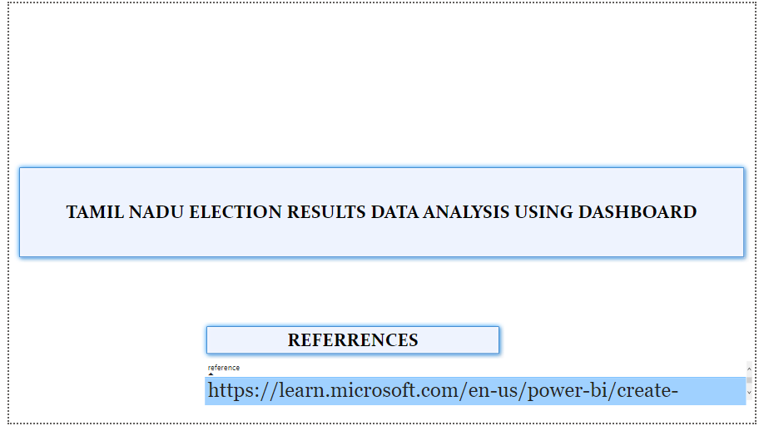

Figure 3.1 Introduction Page

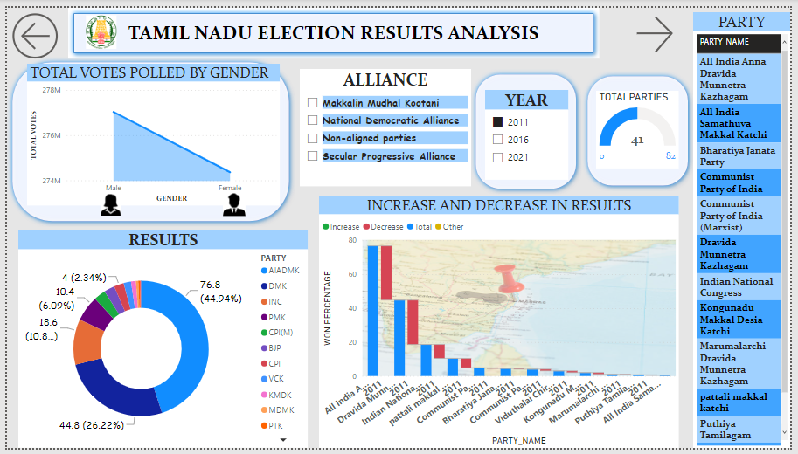

Figure 3.2 Dashboard for the category 1

The above figure 3. describes visualization of the Tamil Nadu Assembly election with party and analysis as the main criteria

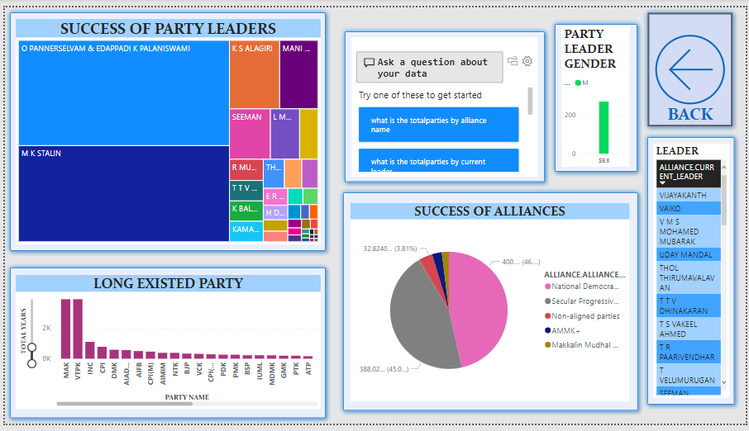

Figure 3.3 Dashboard for the category 2

## **3.3 Inferences**

**Results Of The Tamil Nadu Assembly Election 2011**

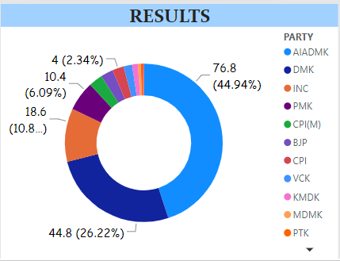

Figure 3.4 Results of The Tamil Nadu Assembly Election 2011

By inferring the Tamil Nadu assembly election which was held in 2011, the results are in favor of the party named AIADMK, which has won the election with 44.94%. The party which is appointed as the opposing party is the DMK with a percentage of 26.22%. The results are based on the votes polled on the both postal and in the general ward.

**Results of the Tamil Nadu Assembly election 2016**

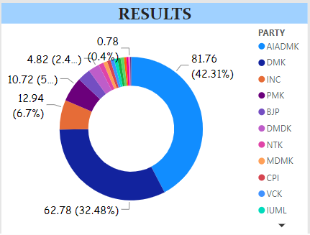

Figure 3.5 Results of The Tamil Nadu Assembly Election 2016

By inferring the Tamil Nadu assembly election which was held in 2016, the results are in favor of the party named AIADMK All India Anna Dravida Munnetra Kazhagam, which has won the election with 42.31%. The party which is appointed as the opposing party is the DMK Dravida Munnetra Kazhagam with a percentage of 32.48%. The results are based on the votes polled on the both postal and in the general ward.

**Results Of The Tamil Nadu Assembly Election 2021**

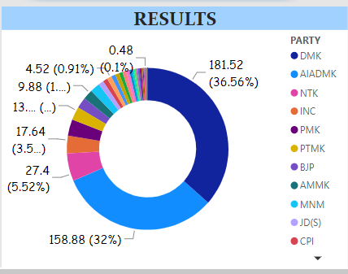

Figure 3.6 Results of The Tamil Nadu Assembly Election 2021

According to the results of the 2016 Tamilnadu assembly election, which was won by the DMK Dravida Munnetra Kazhagam party with 36.56% of the vote, the results are favorable. The AIADMK All India Anna Dravida Munnetra Kazhagam, with a percentage of 32%, has been designated as the opposing party. The votes cast in both the general ward and the postal polls were used to determine the outcome.

**Compare The Assembly Elections of The Years 2011 & 2016**

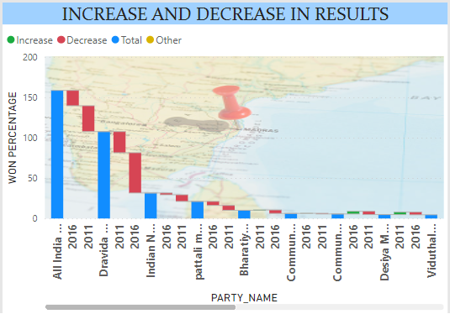

Figure 3.7 Comparing the Assembly Election of The Years 2011 & 2016

By comparing the assembly elections of the year 2011 & 2016, it is inferred that there is a tremendous decrease in the won percentage of the party DMK Dravida Munnetra Kazhagam in the year 2016 than the year 2011, for the party AIADMK All India Anna Dravida Munnetra Kazhagam there is a tremendous increase in the results when comparing to the year 2011

The Communist party of India has an increase of the results in the year 2016.It is inferred that the total votes of AIADMK All India Anna Dravida Munnetra Kazhagam is higher than any other party listed.

The winning percentage of the party DMK Dravida Munnetra Kazhagam in the year 2016 compared to the year 2011 for the party AIADMK All India is deduced by comparing the assembly elections of the two years.

When compared to the year 2011, Anna Dravida Munnetra Kazhagam's results have increased significantly. The Communist Party of India has also seen an improvement in its 2016 results. The implication is that the AIADMK All India Anna Dravida Munnetra Kazhagam received more votes overall than any other party on the list.

**Compare the Assembly elections of the years 2021 & 2016**

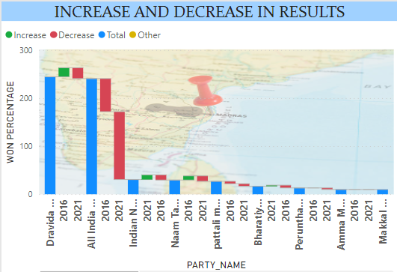

Figure 3.8 comparing the assembly election of the years 2021 & 2016

By comparing the assembly elections of the year 2021 & 2016, it is inferred that there is a huge increase in the votes which are in favor of the party DMK Dravida Munnetra Kazhagam, the decrease in the votes for the party AIADMK All India Anna Dravida Munnetra Kazhaga is greater than of the previous year.

**Compare the Assembly elections of the years 2011 & 2021**

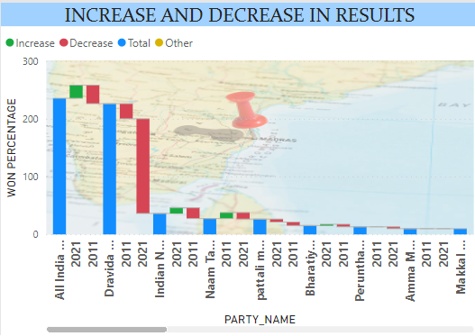

Figure 3.9 comparing the assembly election of the years 2011 & 2021

Comparing the years 2021 and 2011, the political party DMK Dravida Munnetra Kazhagam, suffers a tremendous loss in the votes, as the votes percentage comparing the year 2011, 2021 suffers a great decrease.

**Total Number of parties participated**

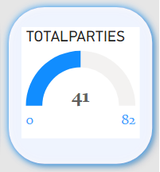

Figure 3.10 total number of parties participated

The total number of parties participating in the assembly election for the years 2011,2016 & 2021 is the same, which is 41.

**Total votes polled gender wise**

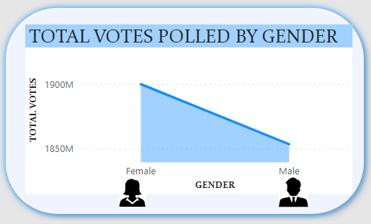

Figure 3.11 total votes polled by gender in 2021

The claim by the individual parties votes polled in the ward by gender plays an important role, as the total votes polled by females are more than the males in the year 2021. Women electors overwhelmingly turned out to be voted in the poll.

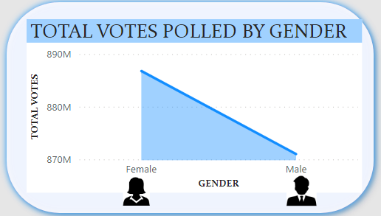

Figure 3.12 total votes polled by gender in 2016

In the year 2016, also women turned out to be voted in a tremendous amount than the other gender.

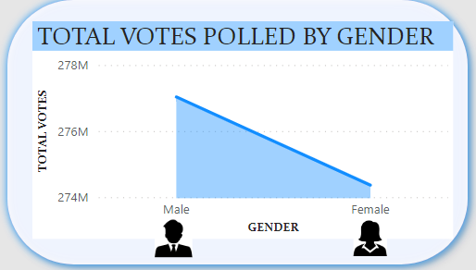

Figure 3.13 total votes polled by gender in 2011

In the year 2011, males preferred to vote more than the female electors

**Results of the year 2016 alliance named National democratic alliance**

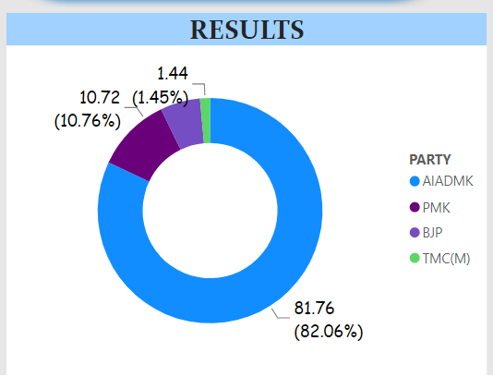

Figure 3.14 Results of The Year 2016 Alliance Named National Democratic Alliance

National democratic alliance includes the parties AIADMK,PMK,BJP AND TMC(M) From the above mentioned four parties the party AIADMK secures the most votes than any other parties mentioned in the national democratic alliance.

**Which alliance won the results of 2021**

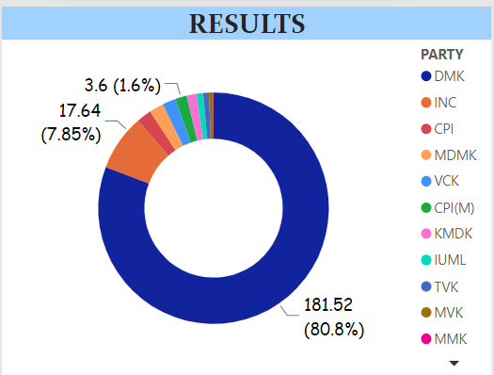

Figure 3.15 Alliance Won In 2021

In the year 2021 the alliance named secular progressive one won the Assembly election of 2021. The parties which were allied were

DMK,INC,CPI,MDMK,VCK,CPI(M),KMDK,IUML,TVK,MVK,MMK,

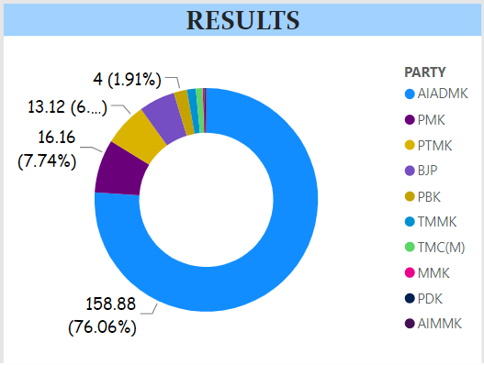

Figure 3.16 Alliance Won In 2011 & 2016

The National democratic alliance won the Assembly elections of 2016 and 2011, Where the two main parties allied were BJP and AIADMK

**CATEGORY 2**

**Visualize the party leader’s gender**

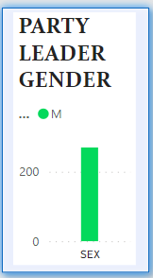

Figure 3.1 Gender of Party Leaders

By visualizing the party leader’s gender, it is evident that the male dominates over the female

**Illustrate the success of the alliance by the leader**

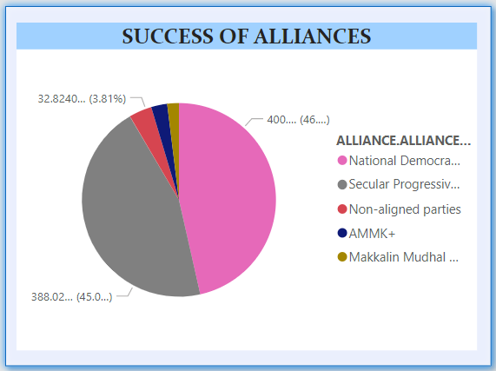

Figure 3.18 Success of The Alliance By The Leaders

By illustrating the success of the alliances, the National democratic alliance holds the most number of successes with order to the year. The alliance played an important role here, because of the alliances the parties are successful in winning the election.

**Most liked leader of people’s choice**

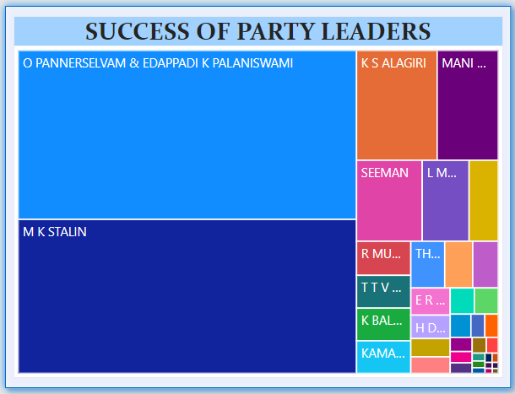

Figure 3.19 Most Liked Leader

The most liked leader by people’s choice would be M.K.Stalin for the year 2021, for the rest of the years the former leader of AIADMK DR.Jayalalitha would be the most liked leader.

**Ask any questions about the data**

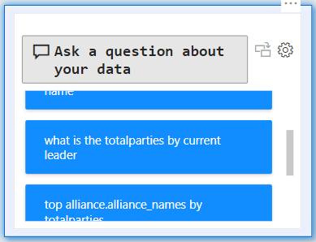

Figure 3.20 Q&A About the Data

This chart provides the people with a live interaction, as it is able to answer any kind of questions about the data, there is no need of dragging the different charts, one Q&A will be there to provide answers for any kind of questions.

**Success rate of the leader named Seeman**

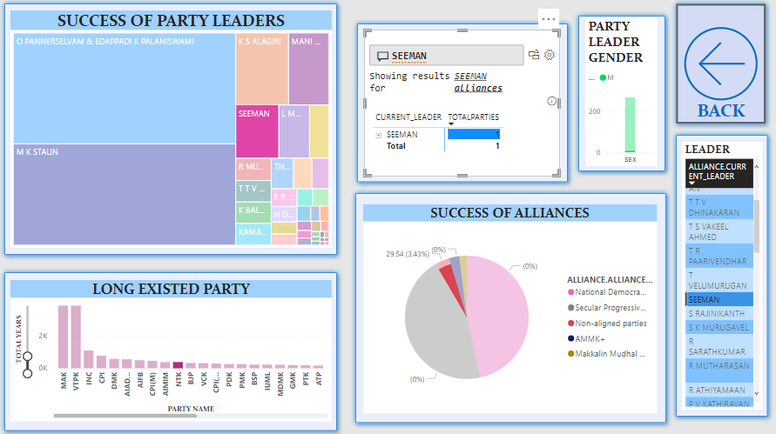

Figure 3.21 Success Rate of Seeman

The above dashboard visualizes the success of the leader Seeman, His party name is Naam Tamilar Katchi which was founded in 1958 and it existed for about 69 years, he holds the top 5th position when coming to success rate,his alliance are Non -aligned so he holds the third position when it comes to alliance

**Longest party that is established so far**

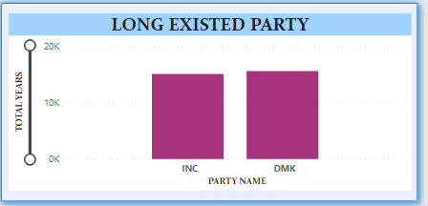

Figure 3.22 Longest Party Existed

The longest existed party is INC, Indian NationalCongress, founded since 1885

**Success rate of the party heads**



Figure 3.23 Success Rate of The Leaders

The success rate of the leader O PANNEERSELVAM & EDAPPADI K PALANISWAMI of AIADMK party is more than any other leaders, next leads M K STALIN.In February 2018, when he had served as Tamil Nadu's chief minister for a year, I referred to him as a "survivor" and a "accidental chief minister." Edappadi K Palaniswami has been in the position for three years and is still doing all of those things. And no, I'm not referring to his swagger in a gray suit in London, although the chief minister's first overseas trip gave the self-described farmer from Salem a touch more sophistication.

When T T V Dhinakaran handed EPS to the chief minister's chair on February 17, 2017, after O Panneerselvam meditated his way to insignificance and V K Sasikala was imprisoned, many people who were not familiar with politics asked, "Palaniswami, who?" After 2.5 years, EPS is firmly established on the throne.

**Does the leader named Vaiko hold an alliance**

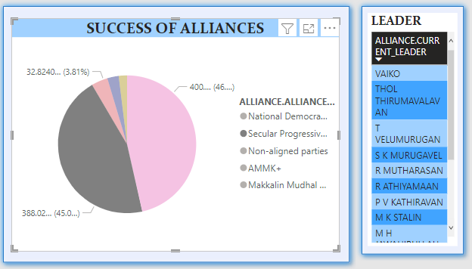

Figure 3.24 Alliance of Vaiko

The leader Vaiko is allied to Secular progressive alliance

**List the top 3 alliances**



Figure 3.25 Top 3 Alliances

The top 3 alliances are

1) National Democratic alliance

2) Secular progressive alliance

3) AMMK+

**Count of male leaders and female leaders**

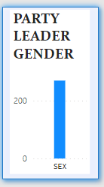

Figure 3.26 Male VS Female leaders

The count of male leaders of the party are 41 and unfortunately there are no female leaders

**CHAPTER 4**

**CONCLUSION AND FUTURE WORK**

**4.1 Recommendations**

Tamil Nadu is one of the most populous states in India and is set to go to the polls in 2021. The state has a long history of political stability and is home to some of the most influential political parties in the country. In order to ensure that the elections are conducted in a fair and transparent manner, it is important to have an effective dashboard that can provide real-time insights into the election process. This is where Power BI comes in.Power BI is a powerful business intelligence tool that can provide real-time insights into any data set. It can be used to create interactive dashboards that can track key metrics such as voter turnout, candidate performance, and election trends. With Power BI, it is possible to create and the future works might include interior insights with the constituency wise results, rather than the whole party. It includes every vote polled in each wards rather than the state.

# **CHAPTER 5**

# **REFERENCES**

1. https://www.theknowledgeacademy.com/in/offers/microsoft-power-bi-certification-training-course/?utm_term=power%20bi%20training&utm_campaign=%5BMicrosoft+Power+BI%5D%5BIN%5D&utm_source=adwords&utm_medium=ppc&hsa_acc=8156085647&hsa_cam=15557838637&hsa_grp=130628451066&hsa_ad=617823466450&hsa_src=g&hsa_tgt=kwd-309870381962&hsa_kw=power%20bi%20training&hsa_mt=e&hsa_net=adwords&hsa_ver=3&gclid=Cj0KCQiAtbqdBhDvARIsAGYnXBOUjMunMQuTg9Seuc3zl5OVYLxiAemEcEMcqObAuGTBBd1P5njXNT8aAgotEALw_wcB
2. John Joseph, Ferdin Joe & Sannasi, Ganapathy. (2022). Translingual Architecture for Prediction of 2021 Tamil Nadu State Assembly Elections.
3. https://www.thehindu.com/elections/tamil-nadu-assembly/tamil-nadu-assembly-polls-where-the-sun-rose-and-leaves-faded/article34477845.ece